SCHOOL

Year 12 Trial WACE Examination, 2013

Question/Answer Booklet

MATHEMATICS 2A/2B
SOLUTIONS

Section Two:

Calculator-assumed

Student Number: In figures

In words

Your name

Time allowed for this section
Reading time before commencing work: ten minutes
Working time for this section: one hundred minutes

Materials required/recommended for this section

To be provided by the supervisor
This Question/Answer Booklet
Formula Sheet (retained from Section One)

To be provided by the candidate
Standard items: pens, pencils, pencil sharpener, eraser, correction fluid/tape, ruler, highlighters

Special items: drawing instruments, templates, notes on two unfolded sheets of A4 paper, and up to three calculators satisfying the conditions set by the Curriculum Council for this examination.

Important note to candidates

No other items may be used in this section of the examination. It is your responsibility to ensure that you do not have any unauthorised notes or other items of a non-personal nature in the examination room. If you have any unauthorised material with you, hand it to the supervisor before reading any further.

Structure of this paper

Section | Number of questions available | Number of questions to be answered | Working time (minutes) | Marks available | Percentage of exam
Section One:  Calculator-free | 7 | 7 | 50 | 50 | 33
Section Two:  Calculator-assumed | 12 | 12 | 100 | 100 | 67
 |  |  | Total | 150 | 100

Instructions to candidates

- The rules for the conduct of Western Australian external examinations are detailed in the Year 12 Information Handbook 2013. Sitting this examination implies that you agree to abide by these rules.

- Write your answers in the spaces provided in this Question/Answer Booklet. Spare pages are included at the end of this booklet. They can be used for planning your responses and/or as additional space if required to continue an answer.
- Planning: If you use the spare pages for planning, indicate this clearly at the top of the page.
- Continuing an answer: If you need to use the space to continue an answer, indicate in the original answer space where the answer is continued, i.e. give the page number. Fill in the number of the question(s) that you are continuing to answer at the top of the page.

- Show all your working clearly. Your working should be in sufficient detail to allow your answers to be checked readily and for marks to be awarded for reasoning. Incorrect answers given without supporting reasoning cannot be allocated any marks. For any question or part question worth more than two marks, valid working or justification is required to receive full marks. If you repeat an answer to any question, ensure that you cancel the answer you do not wish to have marked.

- It is recommended that you do not use pencil, except in diagrams.

Section Two: Calculator-assumed (100 Marks)
This section has twelve (12) questions. Answer all questions. Write your answers in the spaces provided.

Working time for this section is 100 minutes.

Question 8 (6 marks)
At the start of a fete, a lucky dip bin was full with 180 dips. The dips were a mixture of Bendy Pencils, Bug Magnifiers, Silicone Bracelets and Giant Glowing Glasses, all wrapped in similar sized packets.

Of the 180 dips, were Bendy Pencils, 25% were Bug Magnifiers, 54 were Silicone Bracelets and the remainder were Giant Glowing Glasses.

(a) What is the probability that the first person to have a lucky dip randomly picks a Silicone Bracelet? (1 mark)
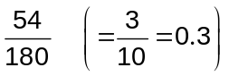

(b) What is the probability that the first person to have a lucky dip does not pick a Bendy Pencil? (1 mark)
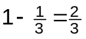

(c) What is the probability that the first person to have a lucky dip randomly picks either a Bendy Pencil or a Bug Magnifier? (2 marks)
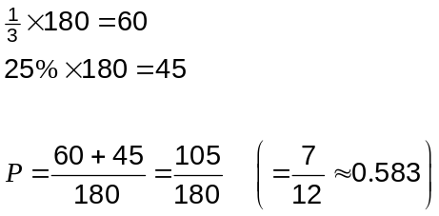

(d) Which is the least likely dip to be chosen by the first person to have a lucky dip? Justify your answer. (2 marks)
Giant Glowing Glasses.

Either compare number of each - 60 BP, 45 BM, 54 SB, 21 GGG
or probability of each - 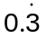 BP, 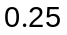 BM, 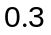 SB, 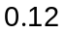 GGG.

Question 9 (11 marks)
The winning margins of the first 16 matches won by a team in a soccer league are shown in the table below. The winning margin is the numbers of goals that the team beat their opponents by.

Winning Margin | Tally | Frequency
1 | 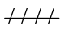 | 11
2 |  | 6
3 | 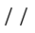 | 2
4 |  | 0
5 |  | 1

The results of the next four matches won by the team are shown in the following table.

Match | 17 | 18 | 19 | 20
Goals for | 2 | 1 | 2 | 3
Goals against | 1 | 0 | 0 | 2
Winning Margin | 1 | 1 | 2 | 1

(a) Complete the winning margin row, add these four results to the tally table above and complete the frequency column. (3 marks)

(b) On the axes below draw a dot frequency plot to represent the 20 winning margins.
(2 marks)
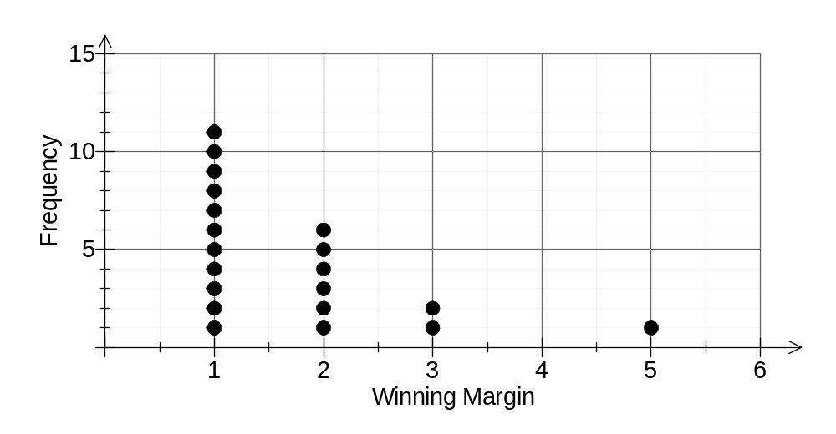

(c) Determine the mean, median and mode of all 20 winning margins. (3 marks)
Mean is 1.7

Median is 1

Mode is 1

(d) State an advantage of displaying the data for the team in a dot frequency graph rather than in a table. (1 mark)
Easier to see how the data is spread out.

(e) Calculate the range of the winning margins of the team and describe the spread of the data as shown in the dot frequency plot. (3 marks)
Range is 4.

Data is clustered around the low winning margins, with the winning margin of 5 looking like at outlier.

Question 10 (6 marks)
The three points A, B and C are shown below.
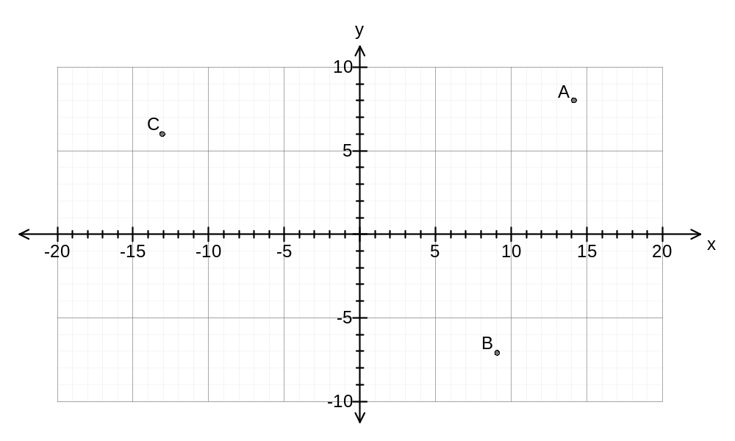
(a) Calculate the distance between B and C. (2 marks)
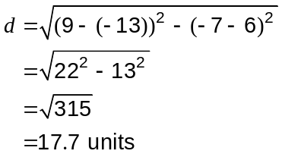

(b) Calculate the gradient of the straight line through A and B. (2 marks)
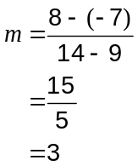

(c) Determine the equation of the straight line through C with a gradient of 2. (2 marks)
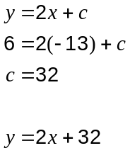

Question 11 (9 marks)
The number of matches played by the past and present members of a netball club is summarised in the table below.
Matches played | Frequency
1 - 20 | 39
21 - 40 | 36
41 - 60 | 25
61 - 80 | 5
81 - 100 | 4
101 - 120 | 1
121 - 140 | 2

(a) State the modal class for this data. (1 mark)
1 - 20 matches played.

(b) Calculate the relative frequency for the 21 - 40 class. (1 mark)
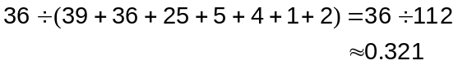

(c) What percentage of the members has played more than 40 matches? (2 marks)
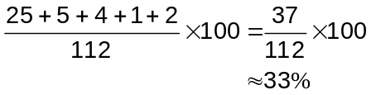

(d) Calculate the mean number of matches played by members of this club. (2 marks)
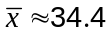

(e) Construct a frequency histogram on the axes below. (3 marks)
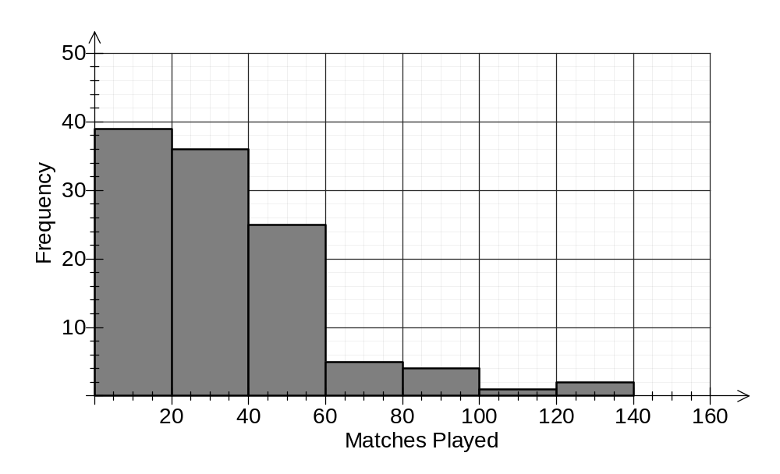

Question 12 (9 marks)
A cinema sells soft drinks in cardboard cups labelled small, regular and large and costing $3.30, $4.40 and $5.50 respectively.

(a) If the capacity of the small, regular and large cups is 380 mL, 460 mL and 600 mL respectively, list the three sizes in order of best to worst value for money. Show your reasoning. (3 marks)
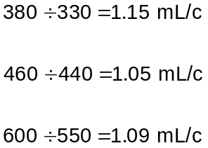

Best value is Small, then Large and Regular is worst.

(b) A customer at the cinema buys a regular cups and 2 large cups for a total of $33.

Write this information as an equation involving and determine the value of . (2 marks)

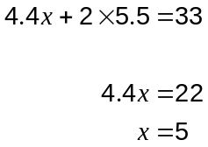

(c) A parent at the cinema buys a small cups and regular cups of soft drink for their child's party. Their bill for these 26 drinks came to $99.

(i) Write an equation using and for the number of drinks bought. (1 mark)
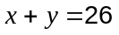

(ii) Write another equation using and for the cost of the drinks. (1 mark)
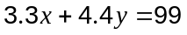

(iii) Using your calculator or otherwise, solve your two equations simultaneously to determine how many of each size can were bought. (2 marks)

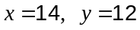
Bought 14 small and 12 regular cups.

Question 13 (7 marks)
A student always waits at the same bus stop after school and catches either the number 205, 255 or 273 bus to get home.

Each day, the probabilities that she catches the 205 or 273 buses are 0.45 and 0.25 respectively.

(a) What is the probability that the student

(i) catches the 255 home? (1 mark)
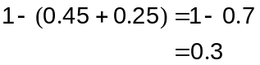

(ii) doesn't catch the 273 home? (1 mark)
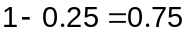

(b) During one school term the student expects to catch the bus home on 47 days. Predict how many times the student will catch each of the three buses. (3 marks)
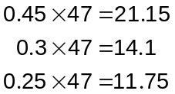

Expect to catch the buses as follows:
205 - 21 times
255 - 14 times
273 - 12 times

(c) Is it likely or unlikely that your predictions in (b) will be realised in practice? Explain your answer. (2 marks)
Unlikely.

The actual outcome of a chance event is unpredictable, but would expect the predictions to be fairly close.

Question 14 (9 marks)
The graph below shows how life expectancy at birth, for females and males in Australia, has changed from 1998 to 2010.
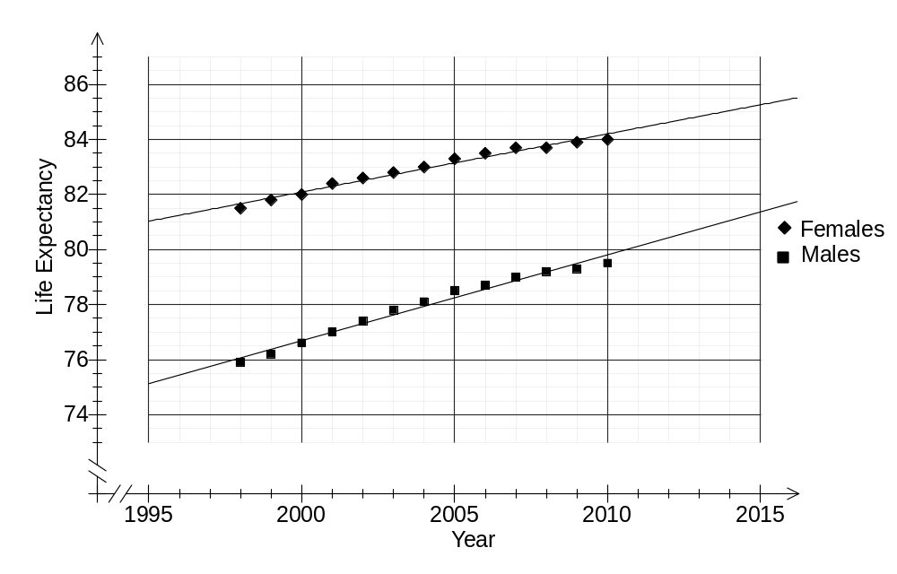

(a) What was the life expectancy at birth for a female in 1998? (1 mark)
81.5 years

(b) How many years did female life expectancy exceed male expectancy in 2002? (1 mark)
5 years

(c) Use a ruler to draw the trend lines for females and males on the graph. (2 marks)

(d) Describe the trend of life expectancy in Australia. (1 mark)

Increasing with time.
(d) Use your trend lines to estimate the life expectancy at birth in 2012 for

(i) females. (1 mark)
84.6 years

(ii) males. (1 mark)
80.4 years

(e) Is the gap between female and male life expectancy at birth increasing or decreasing with time? Justify your answer. (2 marks)
Decreasing.
The trend lines are getting closer together as time goes on.
or
From 2002 to 2012, the gap has decreased by about 1 year.

Question 15 (8 marks)
A rectangular paddock gate 2.4 m wide and 90 cm tall is made by welding lengths of steel tubing together as shown in the diagram.
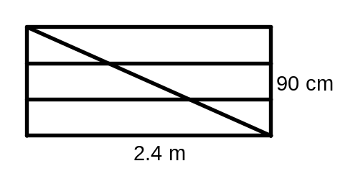
(a) Calculate the length of steel tubing needed for the diagonal, to the nearest cm. (2 marks)

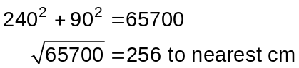

(b) Calculate the length of steel tubing required to construct the gate, rounded up to the nearest whole metre.
(2 marks)
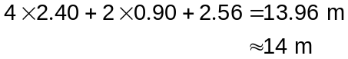

(c) What acute angle, to the nearest degree, does the diagonal make with the horizontal lengths of tubing? (2 marks)
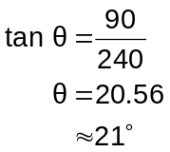

(d) Another rectangular gate was made with a similar design and a height of 90 cm. In this gate, the angle between the diagonal and the vertical side of the gate was 59°. Determine the width of this gate. (2 marks)
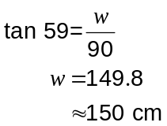

Question 16 (8 marks)
(a) A sequence of numbers starts as follows: 30, 37, 44, 51, 58, ...

(i) Describe in words how to create this sequence. (2 marks)

Start with 30 and keep adding 7.

(ii) What is the eighth number in this sequence? (1 mark)

..., 65, 72, 79

(iii) What is the first number in the sequence to exceed 100? (1 mark)

..., 86, 93, 100, 107

(b) Another sequence is described by the rule 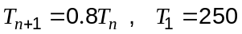.

(i) What is the second term of this sequence? (1 mark)
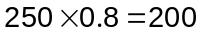

(ii) What is the fifth term of this sequence? (1 mark)

..., 160, 128, 102.4

(iii) State what percentage each term is of the previous term. (1 mark)

80% of previous term.

(iv) Determine the smallest possible value of so that 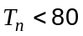. (1 mark)

..., 81.92, 65.536

So smallest is 7.

Question 17 (7 marks)
A pile of wheat is in the shape of cone with a sloping side of length 3.19 m and a base radius of 2.41 m as shown.
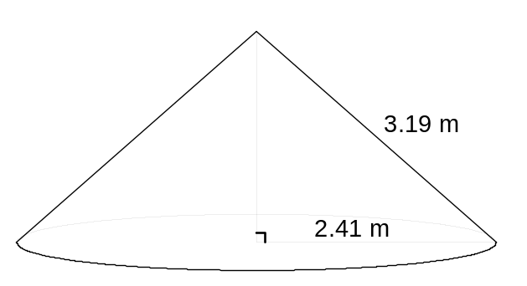

(a) Calculate the area of wheat exposed to the air (that is, the curved surface area of the pile of wheat but not the circular base). (1 mark)

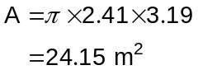

(b) Calculate the height of the pile of wheat, giving your answer in metres to two decimal places. (2 marks)
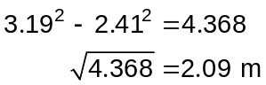

(c) Calculate the volume of wheat in the pile, correct to one decimal place. (2 marks)
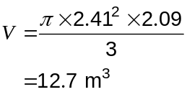

(d) After a truck delivered another load of wheat, the volume of the cone increased to 29.5 m³ and the height increased to 2.75 m. Calculate the new radius of the base of the cone.
(2 marks)
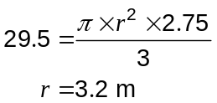

Question 18 (8 marks)
The first three rows of a number pattern are shown below.

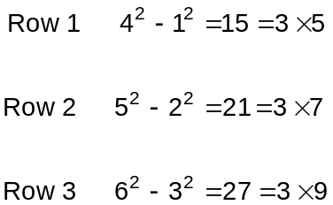

(a) Complete Row 4 of this number pattern in the spaces below. (1 mark)

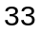
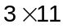
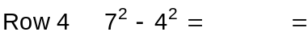

(b) Write down Row 7 of this number pattern. (2 marks)

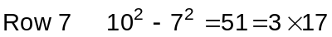

(c) Without doing any calculations, give two reasons why the row of the table shown below cannot be correct. (2 marks)

The first number that is squared should be 3 more than the row number but 180 is 4 more.

The middle number of the pattern is always odd but 1072 is even.

(d) Which row of the number pattern ends in 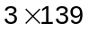? Justify your answer by writing down the complete row. (3 marks)
Row 68 ()

Question 19 (12 marks)
Two solid blocks, one plastic and the other metal, were removed from a cold room and placed in a warm room.

After minutes, the temperature, °C, of the plastic block was given by 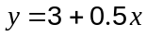 and the temperature of the metal block was given by 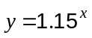.

(a) Calculate the temperatures of the plastic block when 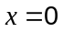 and when 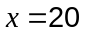. (2 marks)
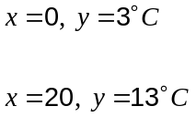

(b) Complete the table below for the metal block, giving temperatures to one decimal place.
(2 marks)

Time, minutes | 0 | 5 | 10 | 15 | 20
Temperature, °C | 1.0 | 2.0 | 4.0 | 8.1 | 16.4

(c) Graph the temperatures of the two blocks on the axes below for the first 20 minutes.
(4 marks)
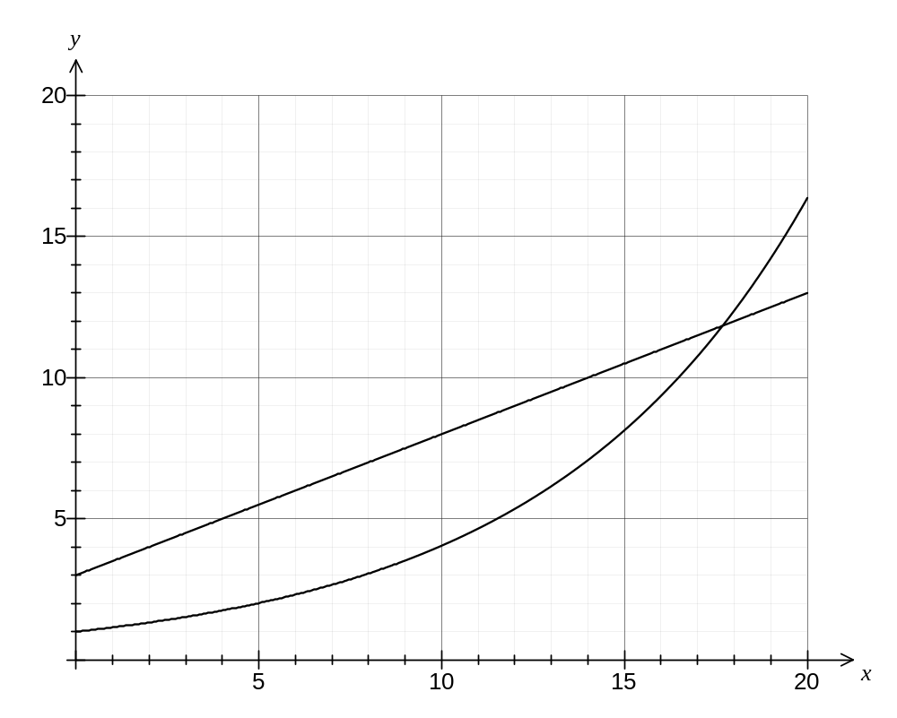

(d) Use your graph to determine at what time, to the nearest minute,

(i) the temperature of the metal block was 7°C. (1 mark)

14 minutes

(ii) both blocks were at the same temperature. (1 mark)

18 minutes

(e) Which block was heating up the fastest, in the first few minutes after they were removed from the cold room? Explain your answer. (2 marks)

The plastic block.

In the first five minutes it heated up by 2.5°C but the metal block only heated up by 1°C.

Additional working space

Question number: _________

Additional working space

Question number: _________

This examination paper may be freely copied, or communicated on an intranet, for non-commercial purposes within educational institutes that have purchased the paper from WA Examination Papers provided that WA Examination Papers is acknowledged as the copyright owner. Teachers within purchasing schools may change the paper provided that WA Examination Paper's moral rights are not infringed.

Copying or communication for any other purposes can only be done within the terms of the Copyright Act or with prior written permission of WA Examination papers.

Published by WA Examination Papers
PO Box 445 Claremont WA 6910

